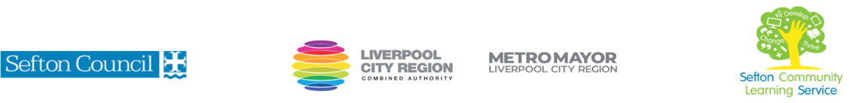
Knitting for beginners 2023/24

(Courses are offered subject to viable numbers.)
This course is for: | Adult learners who want to master the basics of knitting and reading knitting patterns. Knitting is also good for your mental wellbeing, so you might want to join this course for that purpose.
What will I learn: | Course content below is subject to change based on prior knowledge and skills of each cohort.  Week 1  - Induction  - Initial and diagnostic assessment and setting of personal targets  - The basics: needles and yarn. You will learn how to hold the needles and control the yarn.  - Casting on. You will learn to cast on (various methods possible)  Week 2  - Why knit? What can you make and what other benefits are there? You will be introduced to the range of items that can be knitted and learn about the practical and psychological benefits of knitting.  - The core skill: the knit stitch. You will practice the basic knit stitch  Week 3  - Types of yarns and how to choose. You will learn about different types of yarns – natural and man made materials, different thicknesses and characteristics, what types are suitable for what projects.  - The ‘other’ stitch: purl. You will learn to do purl stitch and find out about the variety of different textures this can create.  Week 4  - Decoding patterns. You will be introduced to the common terminology used in patterns and learn to recognise abbreviations.  - Simple increase. You will learn two or more different ways to increase stitches to shape your knitting.  Week 5  - Simple decrease. You will learn two or more different ways to decrease stitches to shape your knitting.  - Needles and notions. You will be introduced to tools and equipment which can help you in your knitting.  Week 6  - Casting off and making up. You will learn how to finish a piece of knitting (various methods possible).  - Review of learning; what will you try next?  You will have the opportunity to discuss and set your individual learning targets with your tutor and discuss the support you might need to ensure you have an enjoyable and meaningful learning experience
Knowledge and skills needed: | This is a course for complete beginners and no prior subject knowledge or skills are required.  However, on this course you will need to:  - follow verbal and written instructions and work through them at your own pace  - listen and join in group discussions  - jot down notes to record relevant information  - keep your work organised  - handle yarns and become comfortable with using knitting needles and other equipment  - learn to recognise specialist terms and abbreviations  - use measurements in mm and inches
Materials needed: | At enrolment, you will need your NI number and proof of benefits (if applicable).  You will need to come prepared to the lessons with an A4 pad, pen and folder or file to keep your work organised, and a suitable fabric bag to store your knitting in.  Your tutor will provide the learning resources, knitting needles and your first ball of yarn, for which a contribution of £2 is requested (payable in the first class).  You may wish, during the course, to purchase more resources to help you develop your knitting: cost of these in total is unlikely to be more than £10.  It will be an advantage, but not essential, if you have access to the internet at home to extend your learning. If needed, your tutor will be able to support you with IT skills required for your course.
How will I learn: | Each session will consist of a dynamic tutor presentation followed by a range of interactive activities.  There will be plenty of revision and consolidation and learning will build on previous learning.  Your progress will be monitored by informal assessment tasks, and you will receive verbal and written feedback from the tutor to help you make good progress.
Progression routes: | On completion of this course, you can progress to expand your craft skills on another course or join an informal craft group to encourage you to keep going and trying new techniques.  Other craft courses offered by SCLS include Visible Mending Techniques, Sewing Machines for Beginners and Mosaics for Beginners. There are also online courses offered by organisations such as Skillshare and follow on courses offered locally (the tutor will discuss this during the course).  If you are interested in creating a small business SCLS offers a variety of ICT and digital courses, covering marketing and other business skills.  Ask your tutor for advice and a copy of the progression ladder.  SCLS offers a range of Functional Skills courses from Entry 1 up to Level 2 if you need to brush up your maths and English skills or require a qualification to support you with your career path.  Sefton @ Work will be able to provide independent information, advice, and guidance to support you making informed choices for progression into further education, volunteering, or employment.

V- July22 (2)

