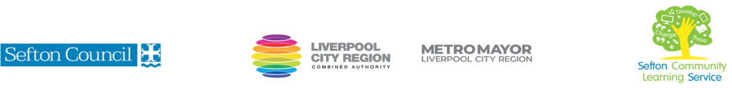
CREATE A CONTEMPORARY FESTIVE RAG WREATH
WORKSHOP

(Courses are offered subject to viable numbers.)
This course is for: | Adult learners who wish to learn how to create a rag wreath using a variety of different materials and techniques. The wreath can be adapted for different seasons. This is a workshop for all levels
What will I learn: | Workshop content below is subject to change based on prior knowledge and skills of each cohort.  - What do you already know? Setting your personal targets  - Introduction to course and tools and materials  - Choosing and adapting a frame for the wreath  - Choosing the base fabric for your wreath  - Preparing the fabric – using different cutting tools to cut the material  - Attaching the fabric strips to the frame  - Choosing and attaching embellishments using a range of techniques  - Adding finishing touches and hanging mechanism  You will have the opportunity to discuss and set your individual learning targets with your tutor and discuss the support you might need to ensure you have an enjoyable and meaningful learning experience
Knowledge and skills needed: | This is a course for all skill levels and will be a mindful experience as well as learning new craft techniques  On this course you will need to:  - follow verbal and written instructions and work through them at your own pace  - listen and join in group discussions  - jot down notes to record relevant information  - have some dexterity using your hands
Materials needed: | At enrolment, you will need your NI number and proof of benefits (if applicable).  Your tutor will provide most of the learning resources, but you will need to come prepared to the workshop with an A4 pad; pen and folder or file to keep your work organised.  It will be an advantage, but not essential, if you have access to the internet at home to extend your learning. All tools and materials will be provided but if you have some special fabric or embellishments you wish to use you are welcome to bring them to class.
How will I learn: | This workshop session will consist of a dynamic tutor presentation followed by a range of practical activities.  Your progress will be monitored by completion of practical tasks (making the wreath) and you will receive verbal feedback from the tutor to help you make good progress.
Progression routes: | On completion of this workshop, you can progress to a variety of sewing and craft courses offered by SCLS, including Embroidery, Basic Sewing Machine Skills or Jewellery Making.  Ask your tutor for advice and a copy of the progression ladder.  SCLS offers a range of Functional Skills courses from Entry 1 up to Level 2 if you need to brush up your maths and English skills or require a qualification to support you with your career path.  Sefton @ Work will be able to provide independent information, advice and guidance to support you making informed choices for progression into further education, volunteering or employment.

