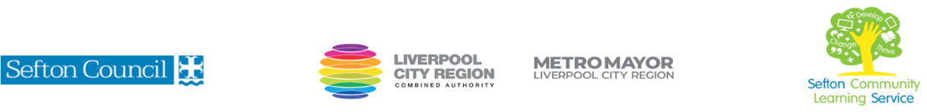
Five Steps to Reclaiming You

(Courses are offered subject to viable numbers.)
This course is for: | Adult learners who would like support removing self-limiting beliefs and barriers to success while gaining a deeper understanding of self-care and self-regulation.
What will I learn: | Course content below is subject to change based on prior knowledge and skills of each cohort.  Week 1  - Induction  - Initial and diagnostic assessment and setting of personal targets  - Belief system Lesson, how we learn it and how it impacts our personal growth.  Week 2  - A review of the belief system  - Self Regulation Lesson – what that feels like in the body & how to identify your triggers  - Ways to help promote positive self-regulation  Week 3  - A Review of self – regulation, how that has impacted you this week  - Gentle yoga flow class, with deep relaxation  - Learning different breathing techniques to use at a practical level  Week 4  - A Review of Yoga practices, how that has impacted you this week  - Self -care Lesson, what that really means and how we don’t put our wellbeing first in today’s society  - Personal alignment with the true self – Yoga and meditation practice.  Week 5  - A Review of self care – how have we implemented those processes  - Gratitude lesson, what gratitude really looks loke and how it is different from gratefulness  - The end of gratefulness  Week 6  - A review of gratitude – how has this impacted you positively this week?  - Reflection Lesson – Look in detail at the elements of the course and how they have impacted your life. We will look in detail at the elements of the course and how they have changed your thought process ad behaviour over the weeks.  - Feedback
 | You will have the opportunity to discuss and set your individual learning targets with your tutor and discuss the support you might need to ensure you have an enjoyable and meaningful learning experience
Knowledge and skills needed: | On this course you will need to:  - follow verbal and written instructions and work through them at your own pace  - listen and join in group discussions  - jot down notes to record relevant information  - keep your work organised in a file  - use a PC/laptop or tablet for research to further your knowledge on topics of interest, including, authors and relevant websites.
Materials needed: | At enrolment, you will need your NI number and proof of benefits (if applicable).  Your tutor will provide most of the learning resources, but you will need to come prepared to the lessons with an A4 pad; pen and folder or file to keep your work organised.  It will be an advantage, but not essential, if you have access to the internet at home to extend your learning.
How will I learn: | Each session will consist of a dynamic tutor presentation followed by a range of interactive activities and class discussions.  There will be plenty of revision and consolidation and learning will build on previous learning.  Your progress will be monitored by informal assessment tasks and you will receive verbal and written feedback from the tutor to help you make good progress.
Progression routes: | On completion of this course, you can progress onto a ‘next five steps’ course and implement the skills you have learnt into your everyday life. This can include attending yoga classes or learning reiki for self-care.  There are many courses on offer at Sefton that put self-care first, including cookery and crafts.  There are also a range of academic courses available for students wishing to invest in their academic profile.  Ask your tutor for advice and a copy of the progression ladder.  SCLS offers a range of Functional Skills courses from Entry 1 up to Level 2 if you need to brush up your maths and English skills or require a qualification to support you with your career path.  Sefton @ Work will be able to provide independent information, advice, and guidance to support you making informed choices for progression into further education, volunteering or employment.

